Exercise 1 : Mocking and Stubbing

ExternalApli.java

package com.example;

public interface ExternalApi {
String getData();
}

MyService.java

package com.example;

public class MyService {

private ExternalApi api;

public MyService(ExternalApi api) {
this.api = api;
}

public String fetchData() {
return api.getData();
}
}

MyServiceTest.java

package com.example;

import static org.junit.jupiter.api.Assertions.assertEquals;
import static org.mockito.Mockito.*;

import org.junit.jupiter.api.Test;

public class MyServiceTest {

@Test
public void testExternalApi() {

// Step 1: Create mock object
ExternalApi mockApi = mock(ExternalApi.class);

// Step 2: Stub the method
when(mockApi.getData()).thenReturn("Mock Data");

// Step 3: Inject mock into service
MyService service = new MyService(mockApi);

// Act
String result = service.fetchData();

// Assert
assertEquals("Mock Data", result);

// Verify interaction
verify(mockApi).getData();
}
}

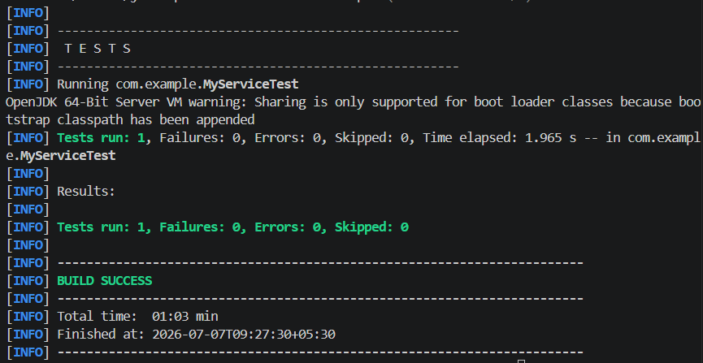

Exercise 2: Verifying Interactions

VerifyInteractionTest.java

package com.example;

import static org.mockito.Mockito.*;

import org.junit.jupiter.api.Test;

public class VerifyInteractionTest {

@Test
public void testVerifyInteraction() {

// Step 1: Create a mock object
ExternalApi mockApi = mock(ExternalApi.class);

// Step 2: Inject the mock into the service
MyService service = new MyService(mockApi);

// Step 3: Call the method
service.fetchData();

// Step 4: Verify that getData() was called
verify(mockApi).getData();
}
}

